Triangle Median
# Source: AI Source: Provided by: [Data Path: Persons Table -> ID Column: 1, Name_En Column: Motasem Essam] -> From: [ChatGPT] on [7/25/2026]
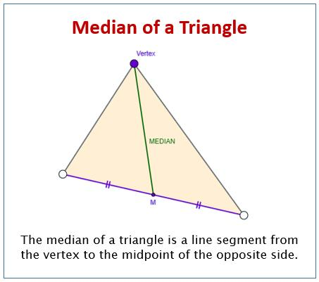
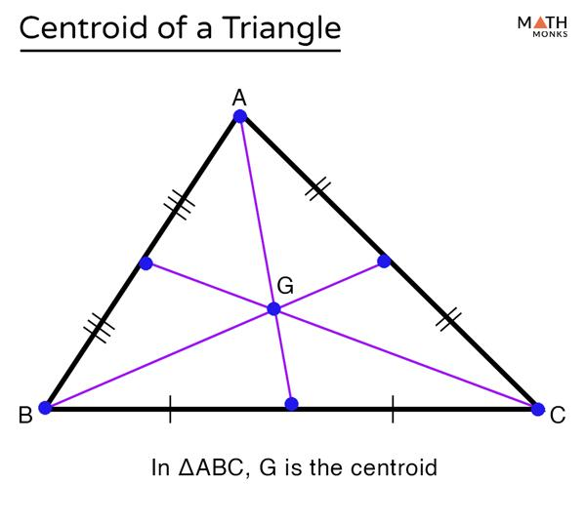
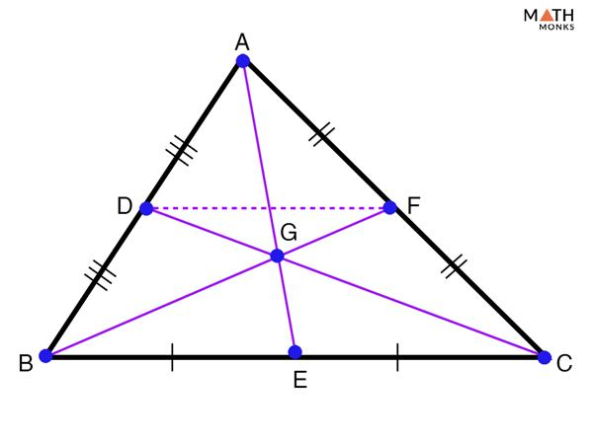

Definition
# Source: AI Source: Provided by: [Data Path: Persons Table -> ID Column: 1, Name_En Column: Motasem Essam] -> From: [ChatGPT] on [7/25/2026]
A triangle median is a line segment that connects a vertex of a triangle to the midpoint of the opposite side.
For triangle $ABC$:
- If $D$ is the midpoint of $BC$, then $\overline{AD}$ is a median.
- Therefore:
$$BD=DC$$
A triangle has three medians, one from each vertex.

Purpose
# Source: AI Source: Provided by: [Data Path: Persons Table -> ID Column: 1, Name_En Column: Motasem Essam] -> From: [ChatGPT] on [7/25/2026]
The median is used to:
- Divide the opposite side into two equal parts.
- Locate the centroid of a triangle.
- Divide a triangle into two triangles with equal areas.
- Help calculate areas and lengths.
- Study the balance or center of mass of a triangular region.
- Establish geometric relationships between the vertices and sides.

Basic Configuration
# Source: AI Source: Provided by: [Data Path: Persons Table -> ID Column: 1, Name_En Column: Motasem Essam] -> From: [ChatGPT] on [7/25/2026]
Consider triangle $ABC$:
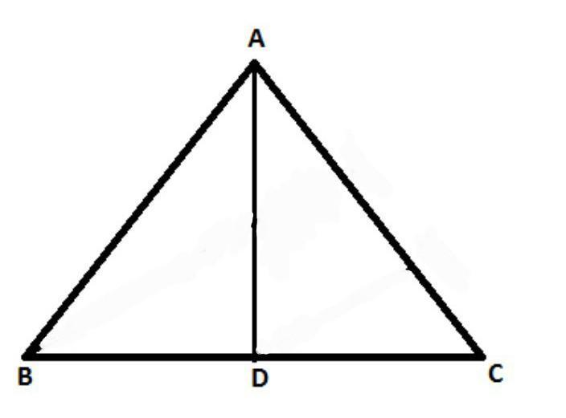
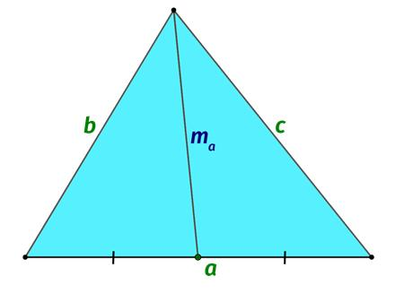
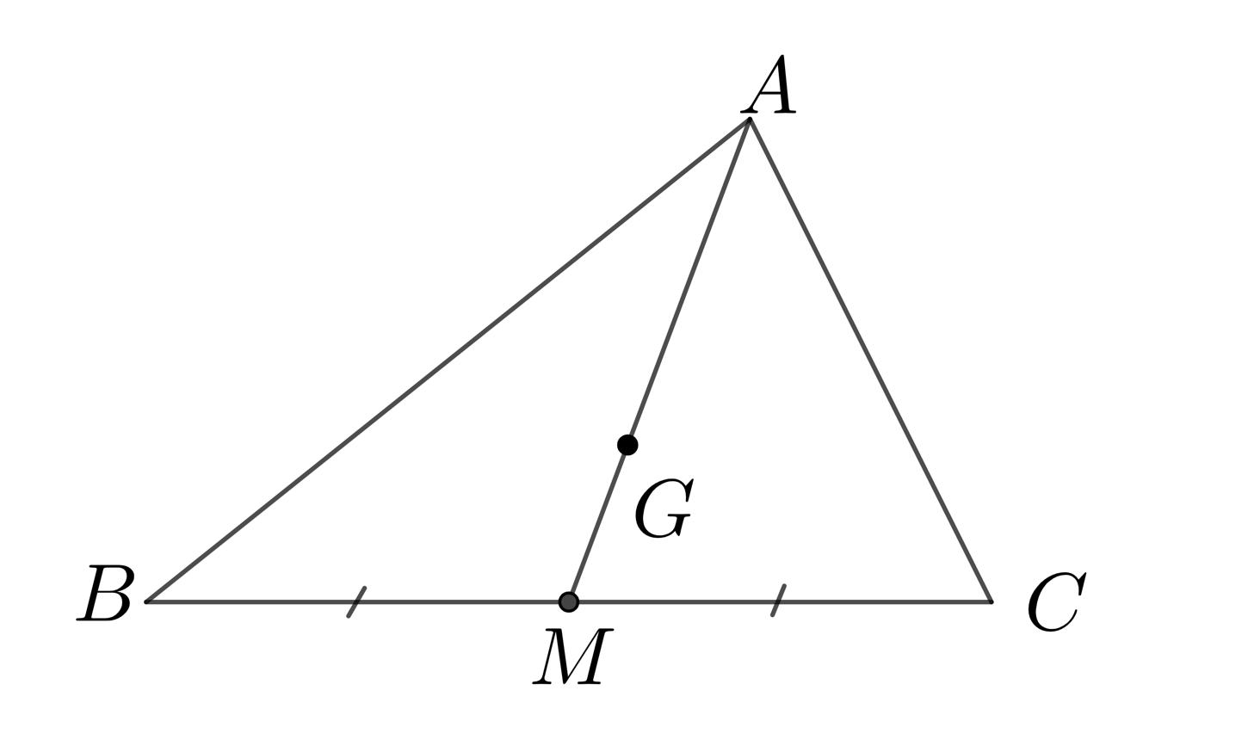
Let $D$ be the midpoint of $BC$.
Then:
$$BD=DC$$
and
$$\overline{AD}$$
is the median from vertex $A$.
Similarly:
- $BE$ is the median from $B$.
- $CF$ is the median from $C$.

Mathematical Representation
# Source: AI Source: Provided by: [Data Path: Persons Table -> ID Column: 1, Name_En Column: Motasem Essam] -> From: [ChatGPT] on [7/25/2026]
For triangle $ABC$:
If $D$ is the midpoint of $BC$:
$$D=\text{midpoint}(B,C)$$
then:
$$BD=DC$$
and:
$$\boxed{\overline{AD}\text{ is a median}}$$
Midpoint Coordinates
If:
$$B(x_{1},y_{1}), C(x_{2},y_{2})$$
then the midpoint $D$ is:
$$\boxed{D\left(\frac{x_{1}+x_{2}}{2},\frac{y_{1}+y_{2}}{2}\right)}$$
Therefore, the median from $A$ is the segment connecting $A$ to this midpoint.

Important Properties

1. Every triangle has three medians
# Source: AI Source: Provided by: [Data Path: Persons Table -> ID Column: 1, Name_En Column: Motasem Essam] -> From: [ChatGPT] on [7/25/2026]
A triangle has exactly three medians:
$$AD, BE, CF$$
Each starts at a vertex and ends at the midpoint of the opposite side.

2. The three medians are concurrent
# Source: AI Source: Provided by: [Data Path: Persons Table -> ID Column: 1, Name_En Column: Motasem Essam] -> From: [ChatGPT] on [7/25/2026]
All three medians intersect at exactly one point called the centroid.

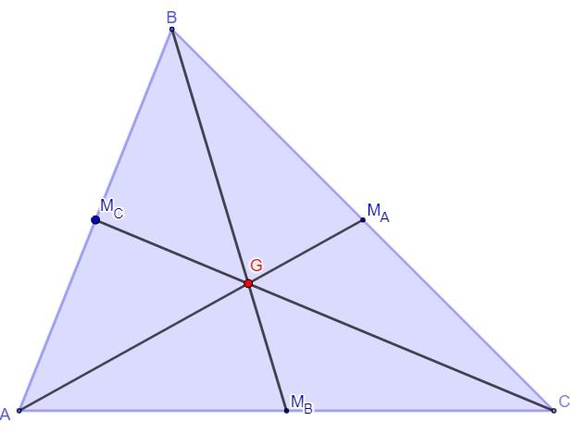
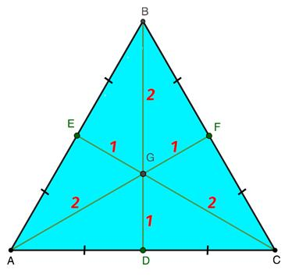
The centroid is usually represented by 𝐺.
$$\boxed{AD∩BE∩CF=G}$$

3. The centroid divides every median in a $2:1$ ratio
# Source: AI Source: Provided by: [Data Path: Persons Table -> ID Column: 1, Name_En Column: Motasem Essam] -> From: [ChatGPT] on [7/25/2026]
The centroid is located two-thirds of the way from the vertex to the midpoint.
For median $AD$:
$$\boxed{AG:GD=2:1}$$
Therefore:
$$AG=\frac{2}{3}AD$$
and:
$$GD=\frac{1}{3}AD$$
This is one of the most important properties of triangle medians.

Examples

Example 1: Identifying a Median
# Source: AI Source: Provided by: [Data Path: Persons Table -> ID Column: 1, Name_En Column: Motasem Essam] -> From: [ChatGPT] on [7/25/2026]
Suppose $D$ lies on $BC$ and:
$BD=7\text{ cm}$ $DC=7\text{ cm}$
Therefore:
$$BD=DC$$
so $D$ is the midpoint of $BC$.
Therefore:
$$\boxed{\overline{AD}\text{ is a median}}$$

Example 2: Finding the Missing Part
# Source: AI Source: Provided by: [Data Path: Persons Table -> ID Column: 1, Name_En Column: Motasem Essam] -> From: [ChatGPT] on [7/25/2026]
A median $AD$ meets $BC$ at its midpoint.
If:
$$BC=18\text{ cm}$$
then:
$BD=DC=\frac{18}{2}$ $\boxed{BD=DC=9\text{ cm}}$

Example 3: Centroid Ratio
# Source: AI Source: Provided by: [Data Path: Persons Table -> ID Column: 1, Name_En Column: Motasem Essam] -> From: [ChatGPT] on [7/25/2026]
Suppose the median $AD$ has length:
$$AD=15\text{ cm}$$
Since:
$$AG=\frac{2}{3}AD$$
we get:
$$AG=\frac{2}{3}(15)=10\text{ cm}$$
and:
$$GD=\frac{1}{3}(15)=5\text{ cm}$$
Therefore:
$\boxed{AG=10\text{ cm}}$
$$\boxed{GD=5\text{ cm}}$$
and:
$$AG:GD=2:1$$

Median and Area
# Source: AI Source: Provided by: [Data Path: Persons Table -> ID Column: 1, Name_En Column: Motasem Essam] -> From: [ChatGPT] on [7/25/2026]
A median divides a triangle into two triangles with equal areas.
If $AD$ is a median of $ABC$, then:
$$\boxed{[ABD]=[ACD]}$$
because $D$ is the midpoint of $BC$, so:
$$BD=DC$$
and both triangles have the same altitude from $A$.

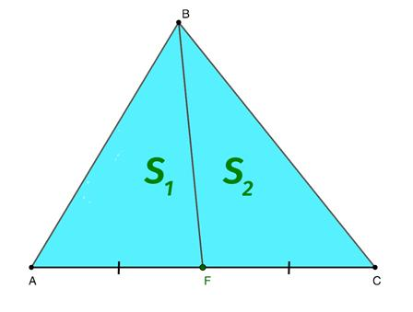
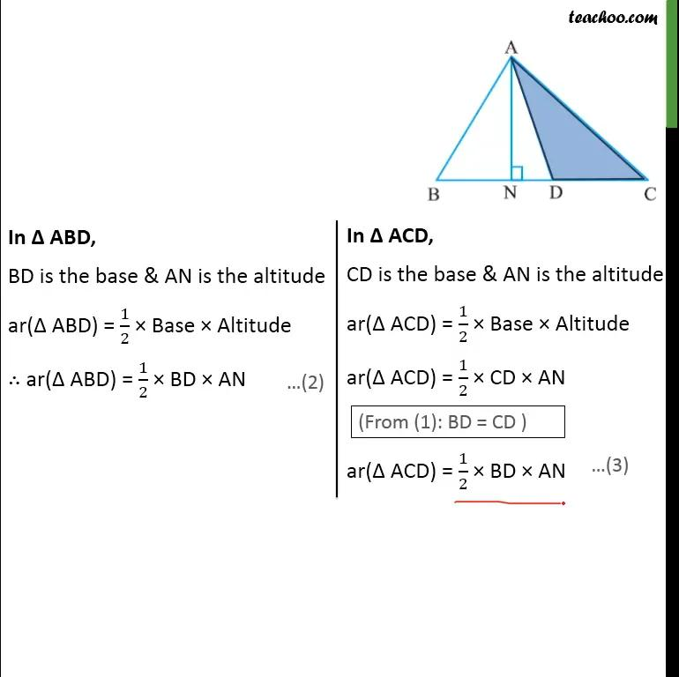
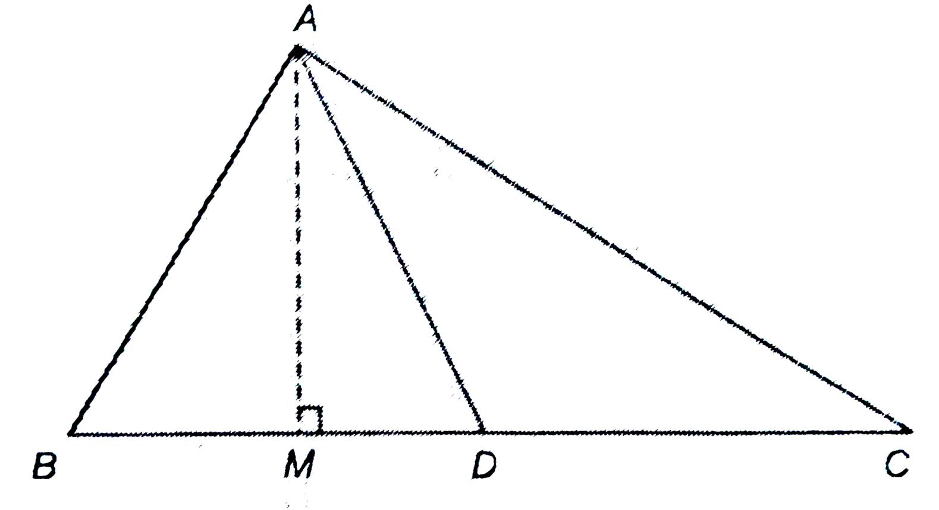

Median Length Formula
# Source: AI Source: Provided by: [Data Path: Persons Table -> ID Column: 1, Name_En Column: Motasem Essam] -> From: [ChatGPT] on [7/25/2026]
If the side lengths of triangle $ABC$ are:
$$a=BC, b=CA, c=AB$$
then the median to side $a$, usually called $m_{a}$, is:
$$\boxed{m_{a}=\frac{1}{2}\sqrt{2b^{2}+2c^{2}-a^{2}}}$$
Similarly:
$$\boxed{m_{b}=\frac{1}{2}\sqrt{2a^{2}+2c^{2}-b^{2}}}$$
and:
$$\boxed{m_{c}=\frac{1}{2}\sqrt{2a^{2}+2b^{2}-c^{2}}}$$

Example 4: Finding a Median Length
# Source: AI Source: Provided by: [Data Path: Persons Table -> ID Column: 1, Name_En Column: Motasem Essam] -> From: [ChatGPT] on [7/25/2026]
Suppose:
$$a=10, b=13, c=15$$
The median to side $a$ is:
$m_{a}=\frac{1}{2}\sqrt{2(13)^{2}+2(15)^{2}-(10)^{2}}$
$=\frac{1}{2}\sqrt{338+450-100}$
$=\frac{1}{2}\sqrt{688}$
$$\boxed{m_{a}=2\sqrt{43}≈13.11}$$

Median in an Equilateral Triangle
# Source: AI Source: Provided by: [Data Path: Persons Table -> ID Column: 1, Name_En Column: Motasem Essam] -> From: [ChatGPT] on [7/25/2026]
In an equilateral triangle, each median has additional properties.
A median is simultaneously:
- an altitude,
- an angle bisector,
- a perpendicular bisector,
- and a line of symmetry.

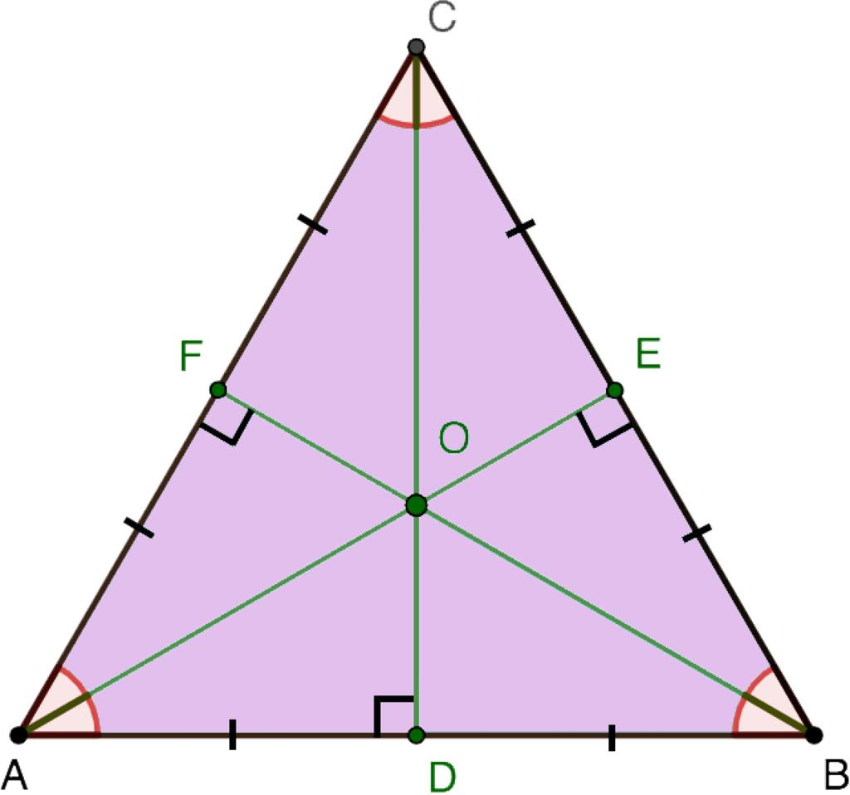
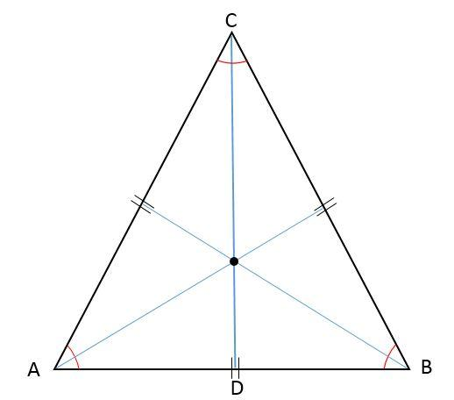
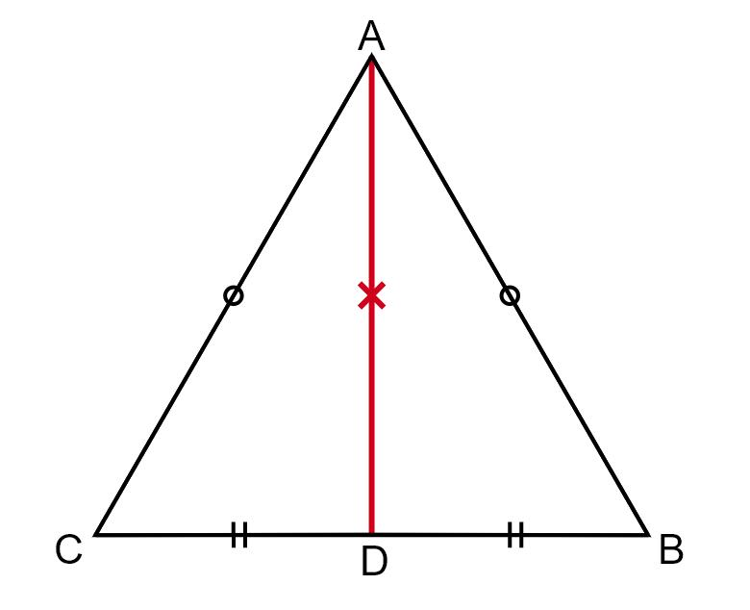
Thus, in an equilateral triangle:
$$\boxed{\text{Median}=\text{Altitude}=\text{Angle Bisector}}$$

Median vs. Related Triangle Segments
# Source: AI Source: Provided by: [Data Path: Persons Table -> ID Column: 1, Name_En Column: Motasem Essam] -> From: [ChatGPT] on [7/25/2026]
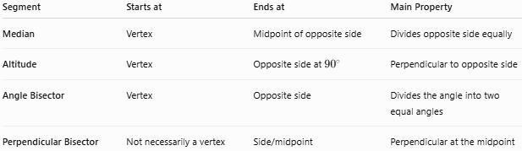
Segment | Starts at | Ends at | Main Property
Median | Vertex | Midpoint of opposite side | Divides opposite side equally
Altitude | Vertex | Opposite side at ${90}^{∘}$ | Perpendicular to opposite side
Angle Bisector | Vertex | Opposite side | Divides the angle into two equal angles
Perpendicular Bisector | Not necessarily a vertex | Side/midpoint | Perpendicular at the midpoint

Important
These segments are not generally the same.
For example, in a scalene triangle:
$$\text{Median}≠\text{Altitude}≠\text{Angle Bisector}$$
But they can coincide in special triangles.

Median vs. Midsegment
# Source: AI Source: Provided by: [Data Path: Persons Table -> ID Column: 1, Name_En Column: Motasem Essam] -> From: [ChatGPT] on [7/25/2026]
Do not confuse a median with a midsegment.
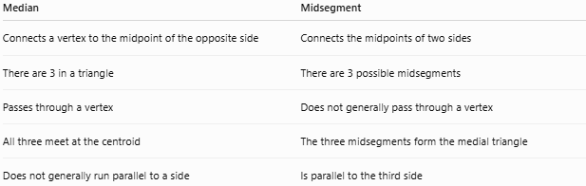
Median | Midsegment
Connects a vertex to the midpoint of the opposite side | Connects the midpoints of two sides
There are 3 in a triangle | There are 3 possible midsegments
Passes through a vertex | Does not generally pass through a vertex
All three meet at the centroid | The three midsegments form the medial triangle
Does not generally run parallel to a side | Is parallel to the third side

Centroid
# Source: AI Source: Provided by: [Data Path: Persons Table -> ID Column: 1, Name_En Column: Motasem Essam] -> From: [ChatGPT] on [7/25/2026]
The point where the three medians intersect is the centroid.

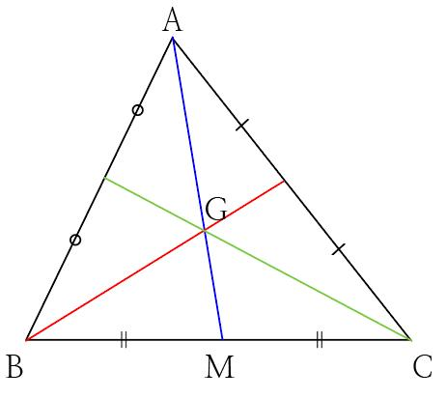
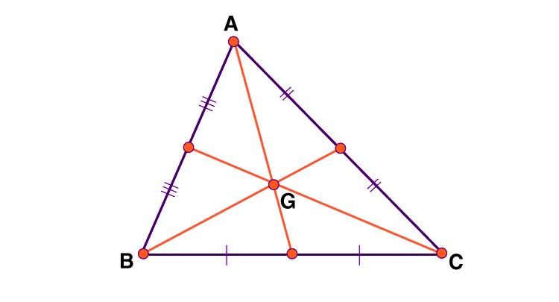
The centroid has an important geometric interpretation: it is the center of mass of a uniform triangular lamina.
For median $AD$:
$$AG:GD=2:1$$
For the other medians, the same ratio applies:
$BG:GE=2:1$ $CG:GF=2:1$

Coordinate Formula for the Centroid
# Source: AI Source: Provided by: [Data Path: Persons Table -> ID Column: 1, Name_En Column: Motasem Essam] -> From: [ChatGPT] on [7/25/2026]
If the vertices are:
$$A(x_{1},y_{1}), B(x_{2},y_{2}), C(x_{3},y_{3})$$
then the centroid $G$ is:
$$\boxed{G\left(\frac{x_{1}+x_{2}+x_{3}}{3},\frac{y_{1}+y_{2}+y_{3}}{3}\right)}$$
Example
For:
$$A(1,2), B(7,2), C(4,8)$$
the centroid is:
$G=\left(\frac{1+7+4}{3},\frac{2+2+8}{3}\right)$ $\boxed{G=(4,4)}$

Real-World Applications
# Source: AI Source: Provided by: [Data Path: Persons Table -> ID Column: 1, Name_En Column: Motasem Essam] -> From: [ChatGPT] on [7/25/2026]
Triangle medians are useful in:
- Engineering — locating the center of mass of triangular components.
- Architecture — analyzing triangular structures.
- Physics — determining the balance point of uniform triangular objects.
- Computer graphics — calculating triangle centers and mesh geometry.
- Surveying — working with triangular regions.
- Geometry and coordinate systems — locating the centroid.

Applications
# Source: AI Source: Provided by: [Data Path: Persons Table -> ID Column: 1, Name_En Column: Motasem Essam] -> From: [ChatGPT] on [7/25/2026]
Triangle medians are commonly used for:
- Finding the centroid.
- Dividing a triangle into equal-area regions.
- Calculating the lengths of medians.
- Coordinate geometry.
- Triangle construction.
- Geometric proofs.
- Area calculations.
- Center-of-mass calculations.

Advantages
# Source: AI Source: Provided by: [Data Path: Persons Table -> ID Column: 1, Name_En Column: Motasem Essam] -> From: [ChatGPT] on [7/25/2026]
- Provides a simple way to locate the centroid.
- Divides the triangle into two equal-area triangles.
- Has a precise $2:1$ centroid ratio.
- Works for every type of triangle.
- Has useful coordinate and algebraic formulas.
- Helps connect geometry with physics and mechanics.

Limitations
# Source: AI Source: Provided by: [Data Path: Persons Table -> ID Column: 1, Name_En Column: Motasem Essam] -> From: [ChatGPT] on [7/25/2026]
- A median does not generally form a ${90}^{∘}$ angle with the opposite side.
- A median does not generally bisect the opposite angle.
- The median length cannot generally be found by simply taking half of the opposite side.
- The median and altitude are different in most scalene triangles.

Key Points
# Source: AI Source: Provided by: [Data Path: Persons Table -> ID Column: 1, Name_En Column: Motasem Essam] -> From: [ChatGPT] on [7/25/2026]
- A median connects a vertex to the midpoint of the opposite side.
- Every triangle has three medians.
- Each median divides the opposite side into two equal segments.
- The three medians intersect at the centroid.
- The centroid divides each median in a:
$$\boxed{2:1}$$
ratio, measured from the vertex.
- A median divides a triangle into two equal-area triangles.
- In an equilateral triangle, a median is also an altitude, angle bisector, perpendicular bisector, and line of symmetry.
- The centroid coordinates are the average of the three vertex coordinates.

Conclusion
# Source: AI Source: Provided by: [Data Path: Persons Table -> ID Column: 1, Name_En Column: Motasem Essam] -> From: [ChatGPT] on [7/25/2026]
A triangle median is a fundamental line segment connecting a vertex to the midpoint of the opposite side. Every triangle has three medians, and these three medians always intersect at the centroid. The centroid divides each median in the $2:1$ ratio and serves as the center of mass of a uniform triangular region. Medians are therefore important in geometry, coordinate geometry, physics, engineering, and many practical applications.

